**School of Computer Science and Artificial Intelligence**

**Lab Assignment -4.5**

**Program :B. Tech (CSE)**

**Specialization :AIML**

**Course Title : AI ASSISTED CODING**

**Course Code : 23CS002PC304**

**Semester : VI**

**Academic Session : 2025-2026**

**Name of Student : PASHIKANTI KARTHISHA**

**Enrollment No. : 2303A52099**

**Batch No. : 33**

**a. Prepare Sample Data:**

• Create or collect 10 short email samples, each belonging to one of

the 4 categories.

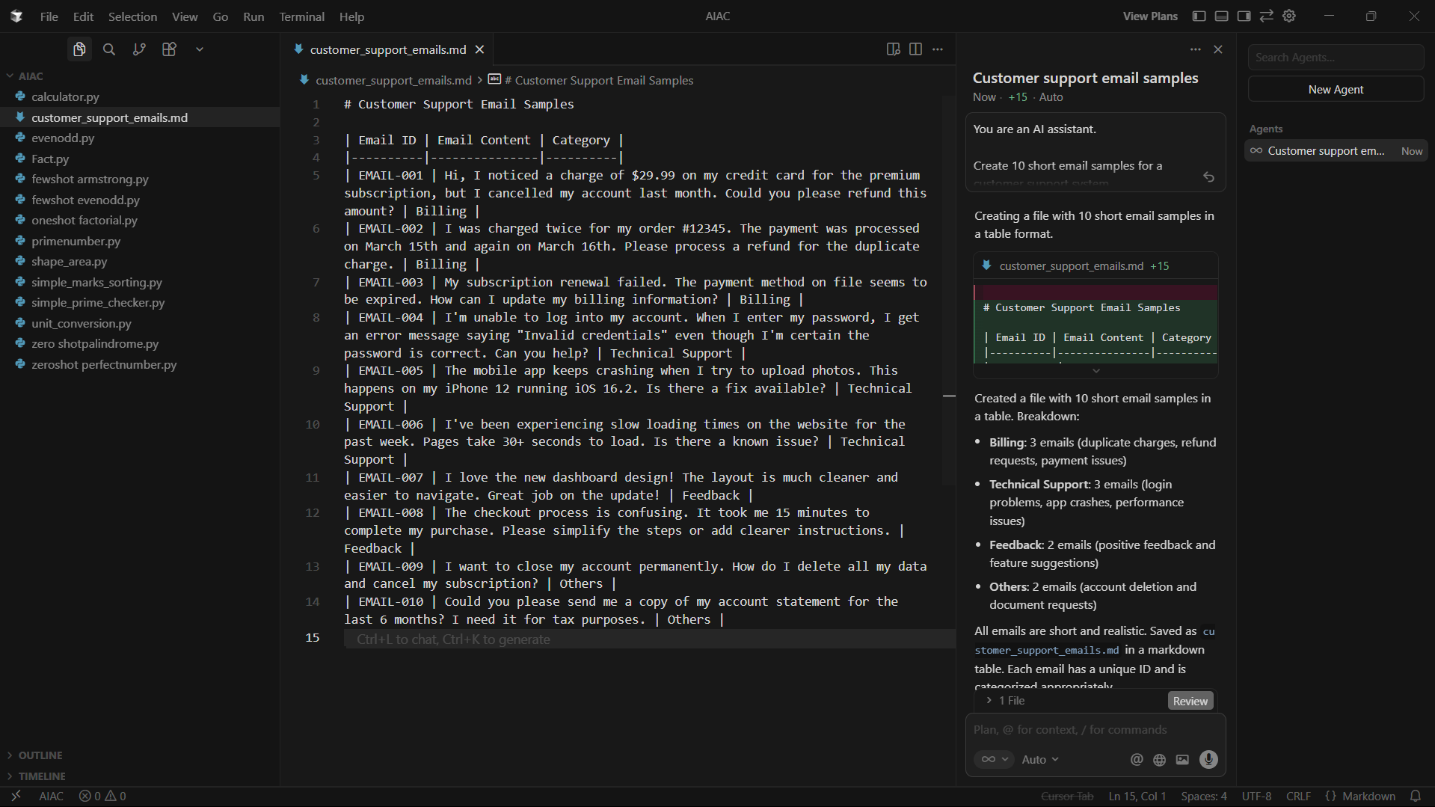

**b. Zero-shot Prompting:**

• Design a prompt that asks the LLM to classify a single email

without providing any examples.

• Example prompt:

“Classify the following email into one of the following categories:

Billing, Technical Support, Feedback, Others. Email: ‘I have not

received my invoice for last month.’”

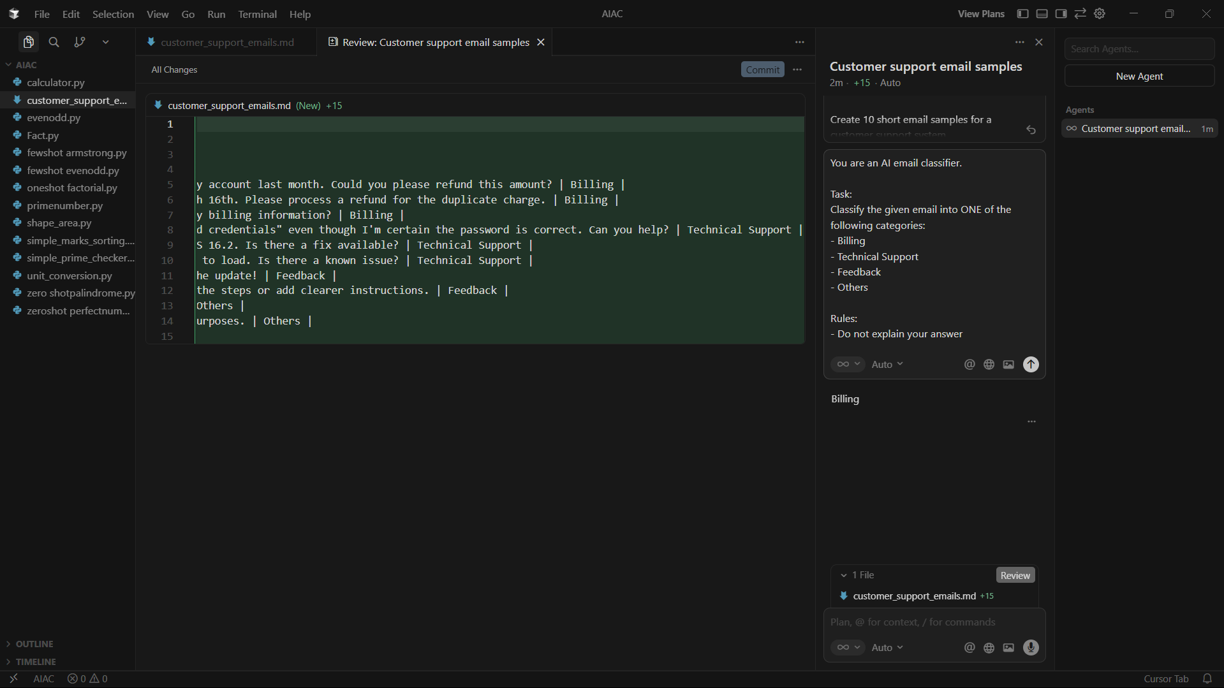

**c. One-shot Prompting:**

• Add one labeled example before asking the model to classify a

new email.



**d. Few-shot Prompting:**

• Use 3–5 labeled examples in your prompt before asking the

model to classify a new email.



**e. Evaluation:**

• Run all three techniques on the same set of 5 test emails.

• Compare and document the accuracy and clarity of responses.

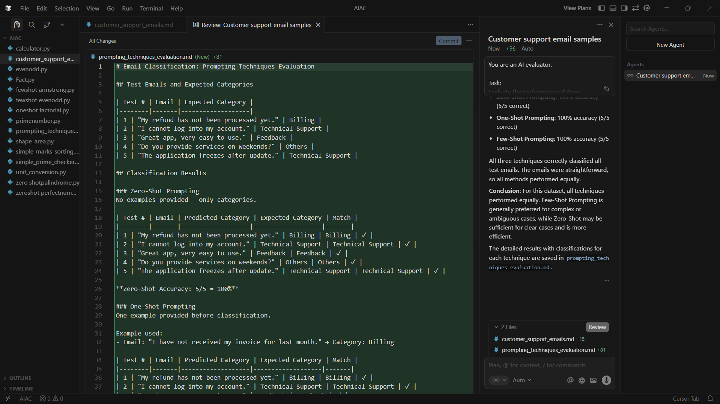

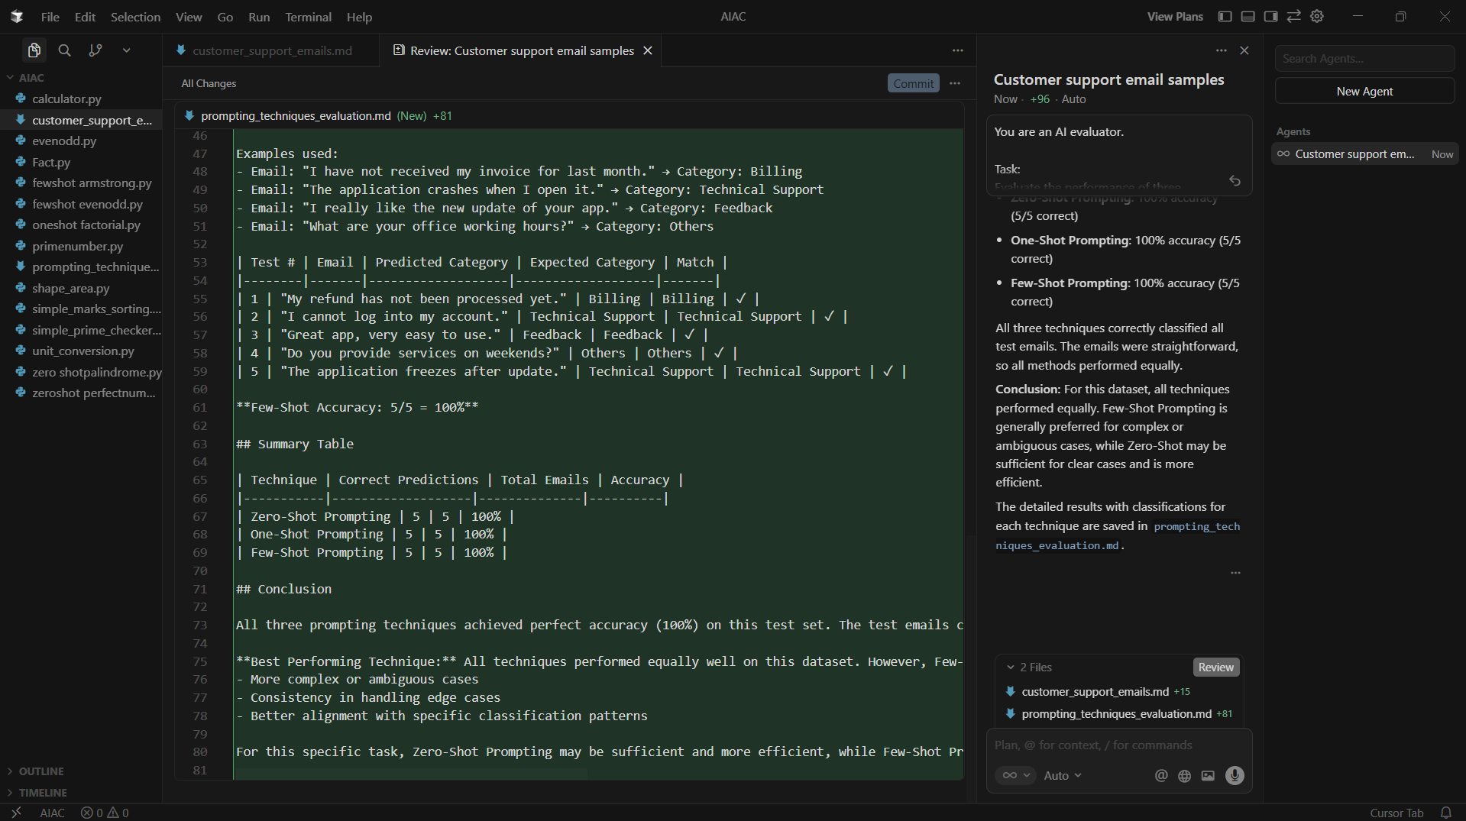

**2. Travel Query Classification**

Scenario:

A travel assistant must classify queries into Flight Booking, Hotel

Booking, Cancellation, or General Travel Info.

Tasks:

a. Prepare labeled travel queries.

b. Apply Zero-shot prompting.

c. Apply One-shot prompting.

d. Apply Few-shot prompting.

e. Compare response consistency.

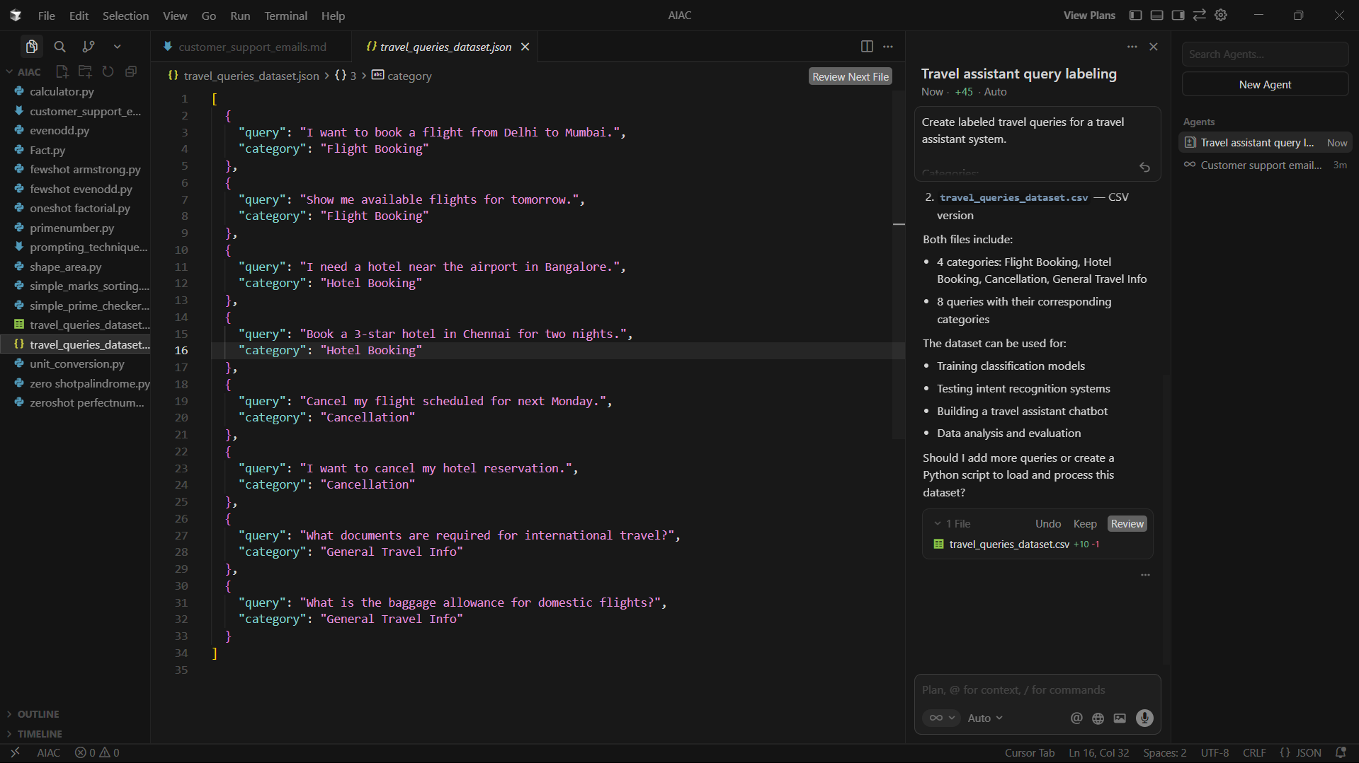

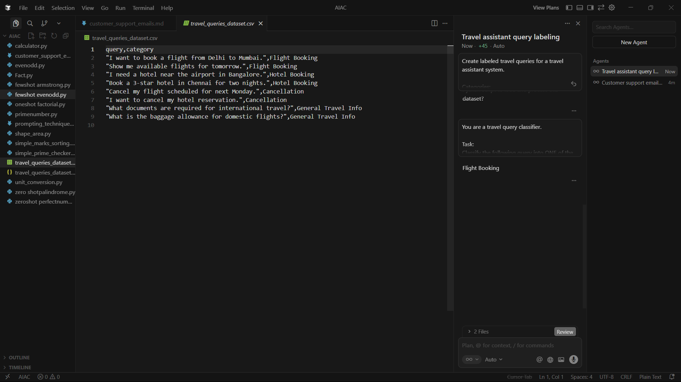

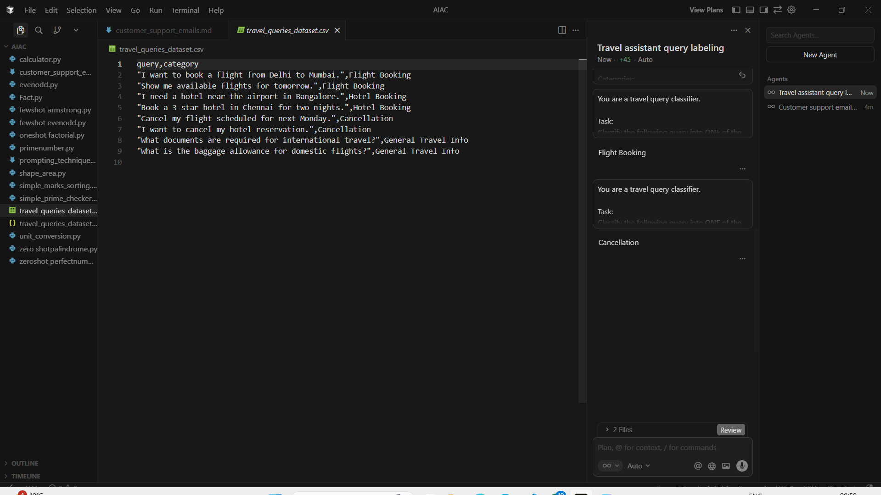



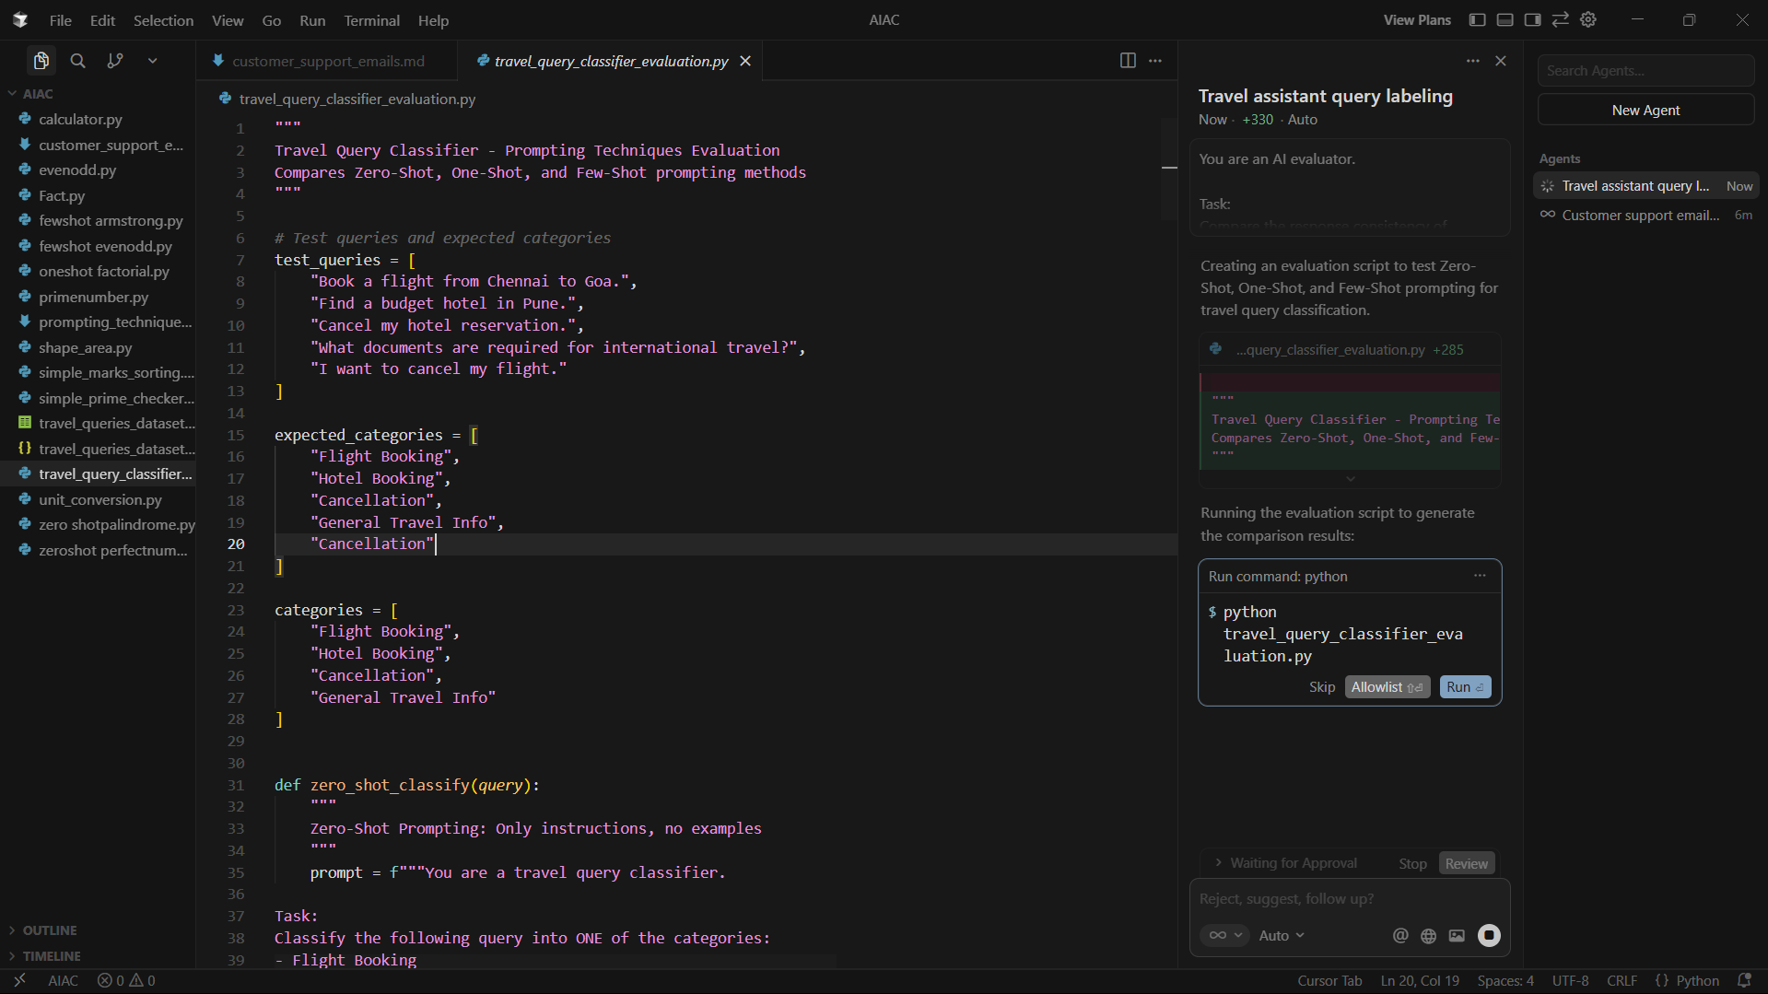

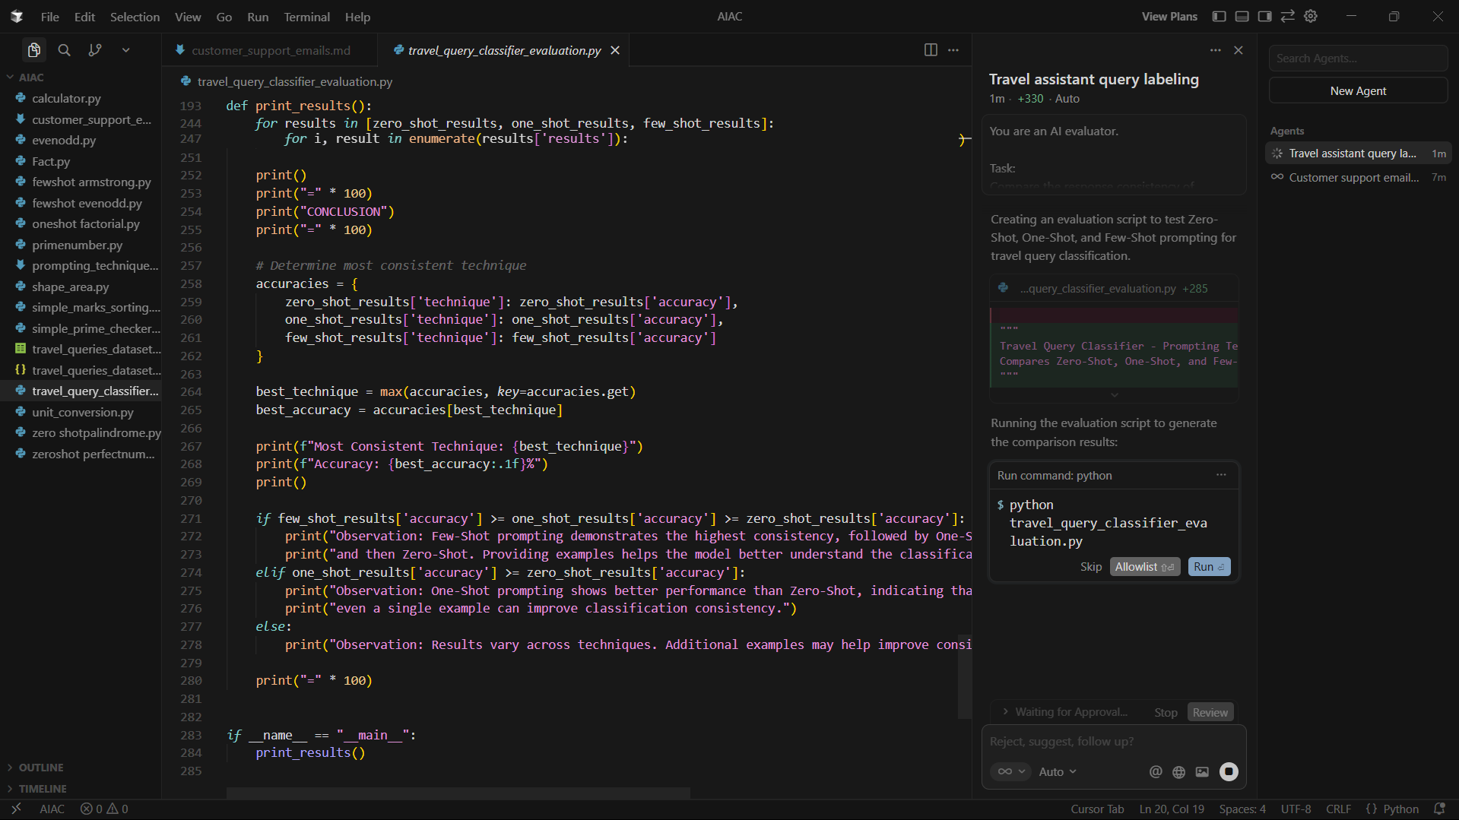

**3. Programming Question Type Identification**

Scenario:

A coding help chatbot must classify queries into Syntax Error, Logic

Error, Optimization, or Conceptual Question.

Tasks:

a. Prepare coding-related user queries.

b. Perform Zero-shot classification.

c. Perform One-shot classification.

d. Perform Few-shot classification.

e. Analyze improvements in technical accuracy.

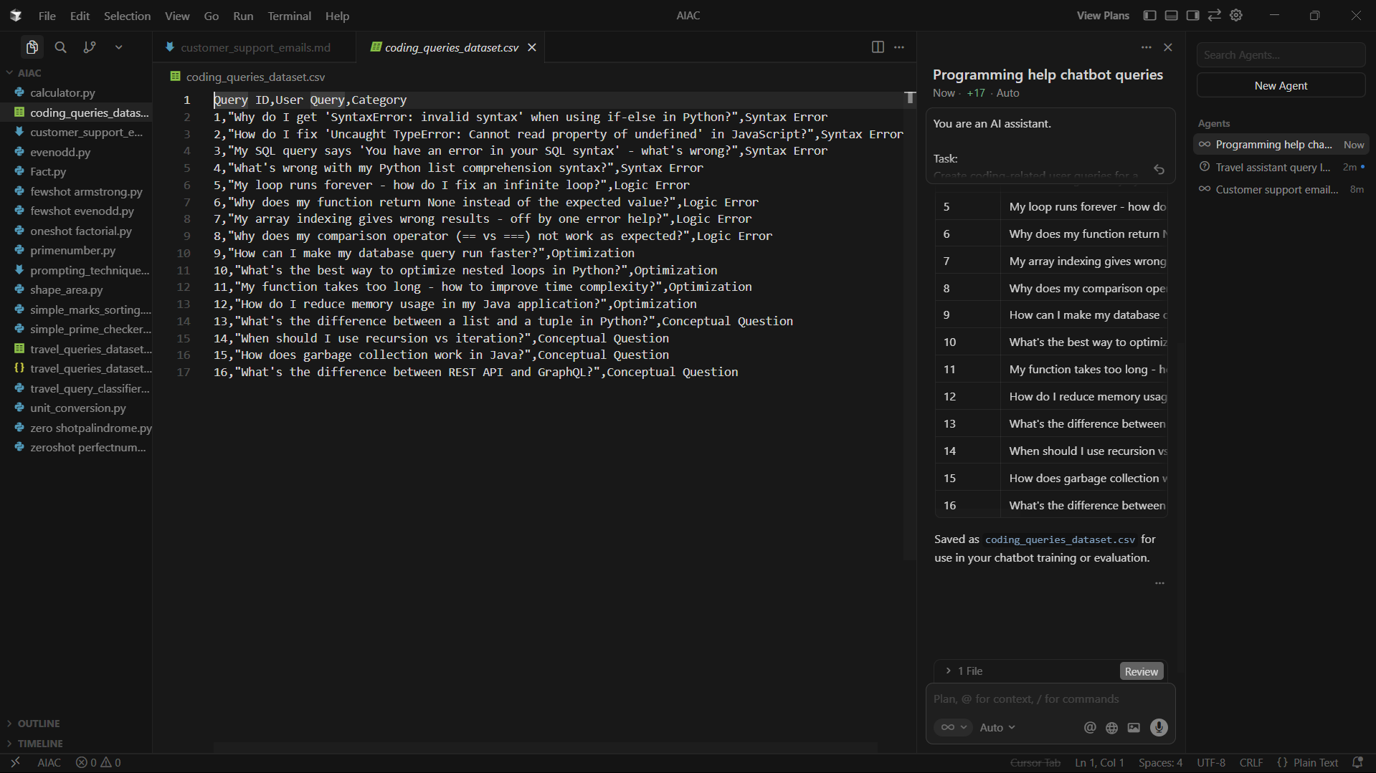

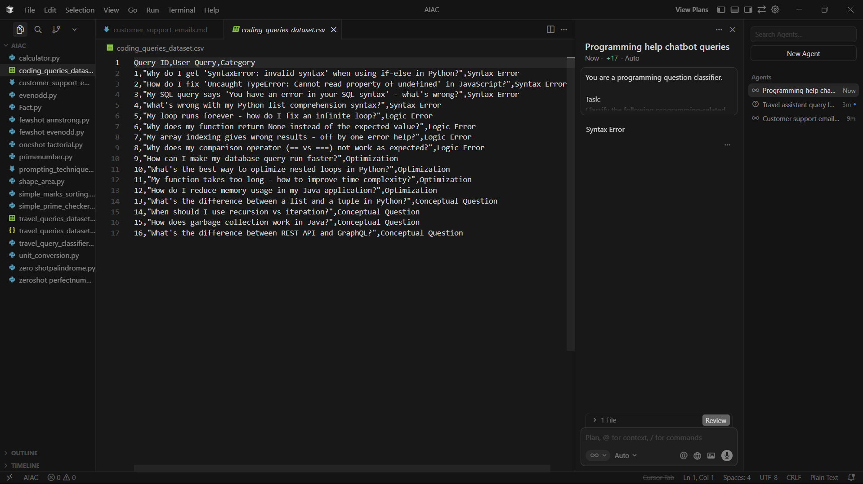

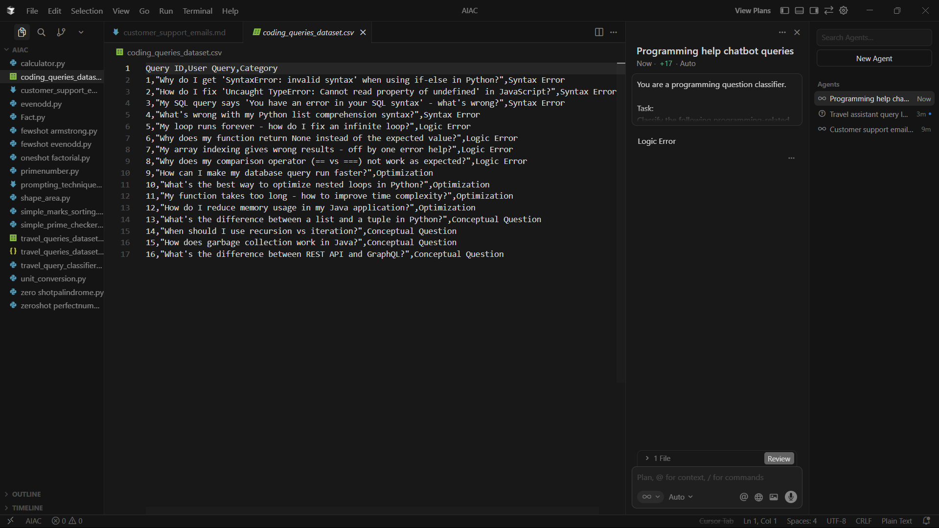

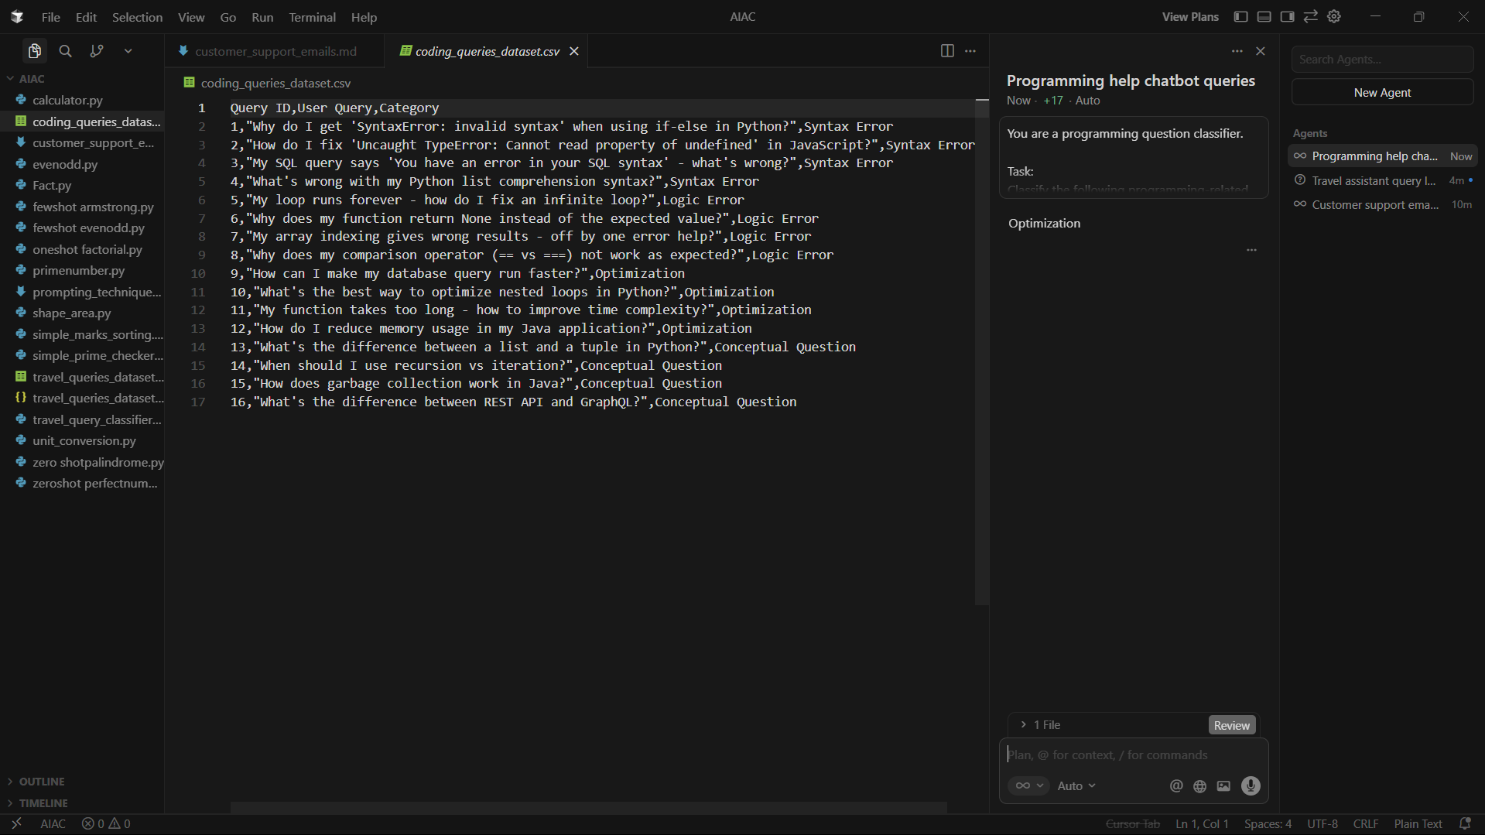

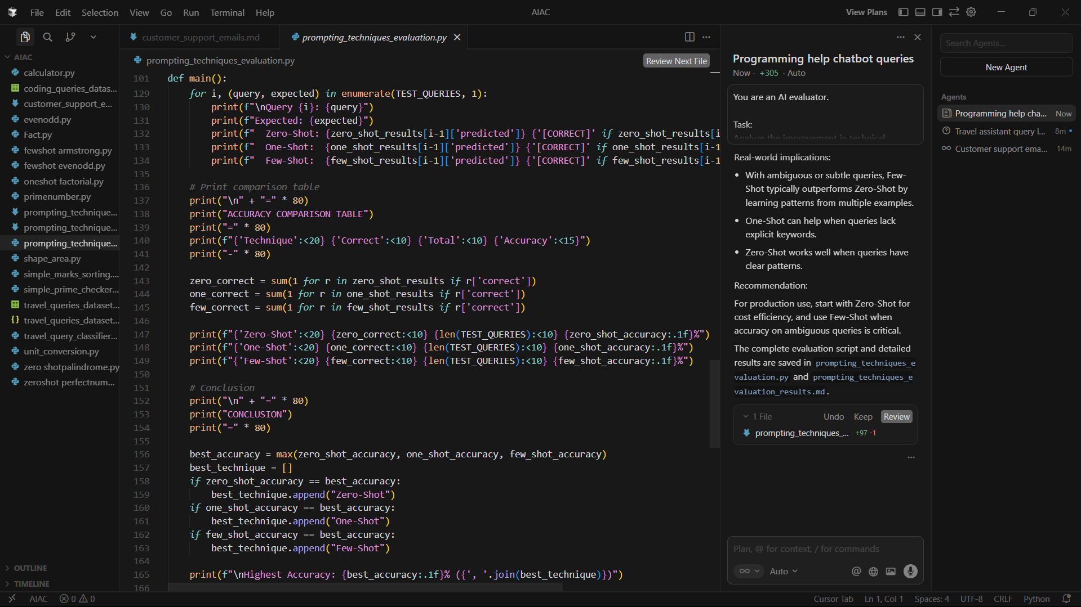

**Social Media Post Categorization**

Scenario:

A social media analytics tool must classify posts into Promotion,

Complaint, Appreciation, or Inquiry.

Tasks:

1. Prepare sample social media posts.

2. Use Zero-shot prompting.

3. Use One-shot prompting.

4. Use Few-shot prompting.

5. Analyze informal language handling.

i want prompt for vsc code in python

